**Mod 5: Critical Thinking**

Alex Mehler

CSU Global

CSC320-1

Farhad Bari

February 18, 2024

**Psuedocode:**

List days

List temps

Double total

Double avg

For(int i = 1, i <= 7, i++){

Print day + “I”

Days.add(input)

Sys.in(“temp” + i)

total = temps.sum

avg = total/7

print please enter day or “week”

string check = input

if (check = “week”)

print days

print temps

print avg

else if (days.contains(Check))

print Check

print temp

else

print error

**

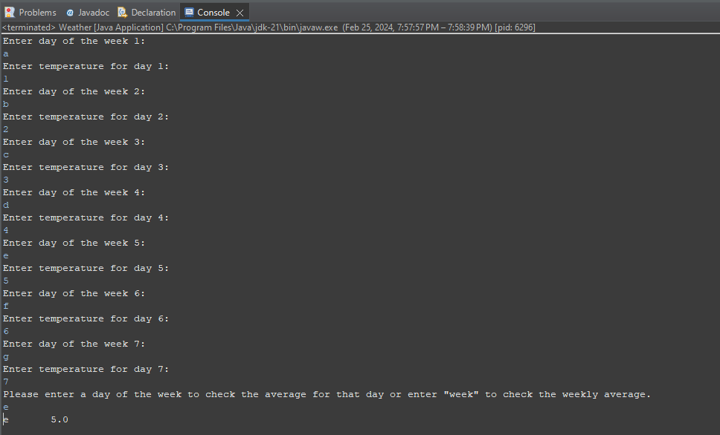

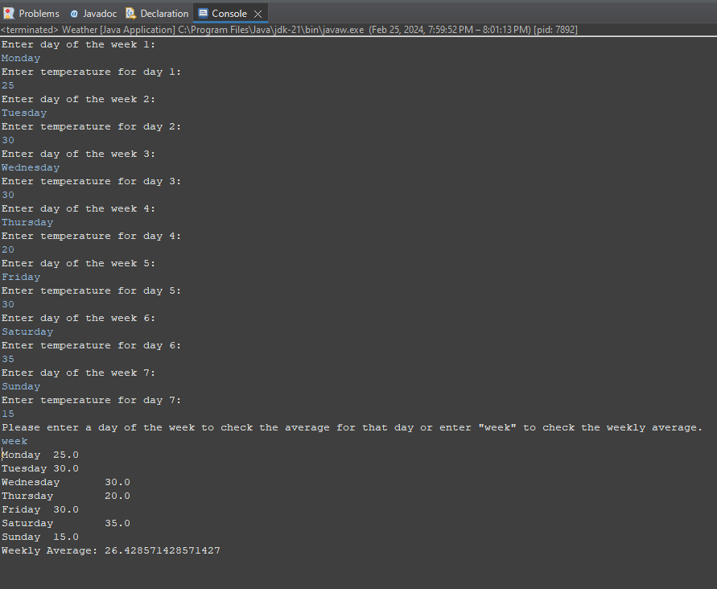

**Git:** <https://github.com/SevRnce/Mod_5>

**Source Code:**

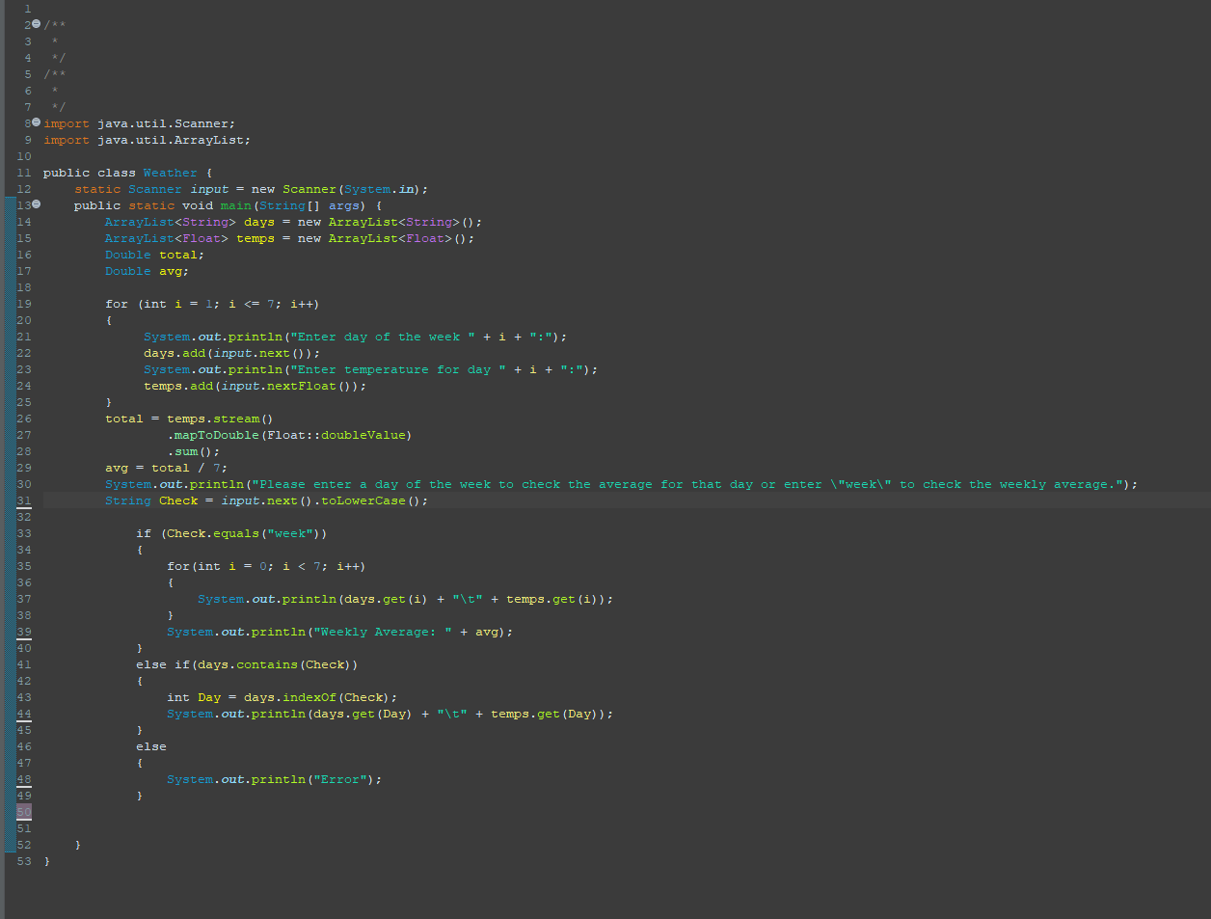

import java.util.Scanner;

import java.util.ArrayList;

public class Weather {

static Scanner input = new Scanner(System.in);

public static void main(String[] args) {

ArrayList<String> days = new ArrayList<String>();

ArrayList<Float> temps = new ArrayList<Float>();

Double total;

Double avg;

for (int i = 1; i <= 7; i++)

{

System.out.println("Enter day of the week " + i + ":");

days.add(input.next());

System.out.println("Enter temperature for day " + i + ":");

temps.add(input.nextFloat());

}

total = temps.stream()

.mapToDouble(Float::doubleValue)

.sum();

avg = total / 7;

System.out.println("Please enter a day of the week to check the average for that day or enter \"week\" to check the weekly average.");

String Check = input.next().toLowerCase();

if (Check.equals("week"))

{

for(int i = 0; i < 7; i++)

{

System.out.println(days.get(i) + "\t" + temps.get(i));

}

System.out.println("Weekly Average: " + avg);

}

else if(days.contains(Check))

{

int Day = days.indexOf(Check);

System.out.println(days.get(Day) + "\t" + temps.get(Day));

}

else

{

System.out.println("Error");

}

}

}